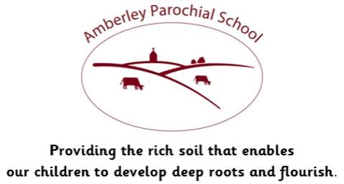

Artists are creative and observant.

Art is about expressing yourself visually.

.

|  |  |  |
| --- | --- | --- |
| Topic: | Skills: | Key Vocabulary: |
| Premium Vector | Cute flower. Hand-drawn sketch of blossom ...  Still life drawing | * Experiment with different grades of pencil; explain choices about use of media. * Use different media to achieve variations in line, texture, tone, shape, pattern, and colour; identify and draw the effect of light. * Use scale and proportion to draw anatomy increasingly accurately, particularly bodies and faces of people. * Use a sketchbook to research, collect and record | annotation, mood, texture, tone, shape, pattern, colour, tone, shade, proportion, still life, |
| Subject: | Duration: | Celebration: |
| Art | 1 week | Online art exhibition |
| Things to support learning at home: | | Focus Value: |
| * Create a still life art work using objects at home | | Perseverance |

