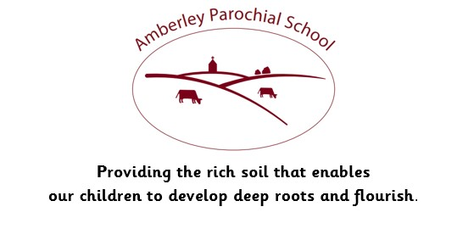

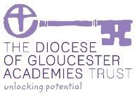

Amberley Parochial School

Curriculum Statement for Science

|  |
| --- |
| **Vision** |
| ***Providing the rich soil that enables our children to develop deep roots and flourish*** |
| **Intent** |
| At Amberley Parochial School, we intend to prepare pupils for life in an increasingly scientifically and technological world; to foster concern and actively care for our environment; to help pupils acquire a growing understanding of scientific ideas; to develop and extend scientific concepts of the world and to develop pupils’ understanding of the collaborative and international nature of science. Through working scientifically pupils, will learn to apply a variety of approaches to answer scientific questions, including observing over time; pattern seeking; identifying, classifying and grouping; comparative and fair testing; and researching using secondary sources. Pupils will collect, analyse and present data to find the answers to questions. Pupils will develop their scientific vocabulary and learn to articulate scientific concepts through experiencing a wide range of scientific enquiries. |
| **Implementation** |
| Our Long Term Plan for Science maps out National Curriculum statutory content for all year groups from EYFS to Year 6, and this content is delivery in a rolling, two-year programme for Years 1 to 6. Science will be delivered in blocks through our Immersion Curriculum, giving the children the opportunity to deepen their understanding whilst being ‘immersed’ in that topic. Key knowledge will be revised regularly. In EYFS pupils are introduced to some of the skills, techniques and vocabulary used in later years though exploring hands-on a range of topics designed to develop their understanding of the world and introduce new language. Scientific knowledge and enquiry skills are developed with increasing depth as pupils move through the year groups and these are mapped out in our long term planning. Our teaching sequences embed knowledge and skills with each lesson building on prior learning. Pupils are introduced to new vocabulary with each termly unit of study and encouraged to use this in their recording and discussions. |
| **Impact** |
| In order to assess pupil progress within the learning of Science, teachers will use formative assessment techniques, including questioning, written work, feedback and discussions with pupils on a regular basis. Teachers may also use end of unit assessments to gage understanding and knowledge. This data will be used to track attainment on SONAR, making valid judgements about a child’s progress within specific topics and year group expectations. In EYFS judgements are made against the Early Learning Goals. The subject leader will use book looks, pupil conferencing, lesson observations and other monitoring to ensure all children have the chance to meet their full potential. |
| **How we support children with Special Educational Needs in this subject area:**  We believe all pupils should have the opportunity to learn to the best of their capabilities through a broad and balanced, inclusive curriculum. This means that every child, including those with a Special Educational Need, should have access to a high standard of ‘Quality First Teaching' throughout the day in every curriculum subject. Teachers use a range of teaching and learning styles and appropriate learning objectives are set for all children with a curriculum matched to their needs. In Science might include classroom organisation and grouping, visual resources, pre and over learning of key vocabulary and questioning, enabling all children to reach their full potential. |