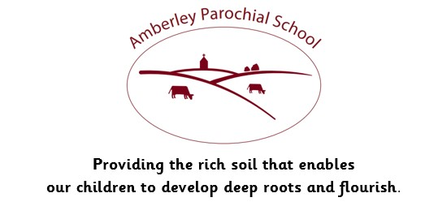

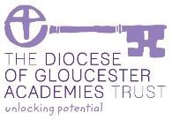

Amberley Parochial School

Curriculum Statement for Geography

|  |
| --- |
| **Vision** |
| ***Providing the rich soil that enables our children to develop deep roots and flourish*** |
| **Intent** |
| At Amberley Parochial School, it is our intention that Geography will inspire pupils with a curiosity and fascination about the world and its people that will remain with them throughout their lives.  We aim to offer opportunities for children to explore the world to develop an understanding of the human and physical world in which they live and their place within it. We aim to promote the children’s interest and understanding about diverse places, people, resources and natural and human environments, together with a deep understanding of the Earth’s key physical and human processes.  It is our intention that Geography will promote children’s spiritual, moral, social and cultural development, helping them to have a greater understanding of their place in the world, and their rights and responsibilities to other people and the environment. We encourage the children to ask questions about the world and provide opportunities for them to develop geographical skills and knowledge to be able to answer them. |
| **Implementation** |
| At Amberley, we want our curriculum to ignite curiosity, inspire a love of learning and build knowledge and skills, giving our children exciting experiences, which inspire awe and wonder in the world around them. Geography is taught in a block to immerse pupils in their learning. This immersion enables children to build on their learning in a meaningful way, making links with prior and current ideas and concepts.  In the Early Years Foundation Stage, children begin by observing the local area and community. This is then compared to other countries and how life is the same and/or different.  In Key Stage One, children expand on their prior learning through a more in-depth study of mapwork, relating this to the local area. Building on this, they then learn to name and locate the four countries in the UK, as well as their key physical and human features. Later within the key stage, children then learn to name and locate the world’s oceans and continents, referring back to their prior learning before comparing our local area with a place outside of the UK.  Within Lower Key Stage Two, the children begin to explore more of the United Kingdom and Europe through comparing regions and exploring alternate land uses. With cross-curricular links made to History topics within each year group, pupils also study the development of settlements and consider how these have changed over time.  Our Upper Key Stage Two curriculum is focused around more in-depth studies of North and South America, studying these continents closely to compare and contrast their physical and human geography. The children continue to make links with their prior learning, allowing them to have a deeper knowledge of diverse places, people, resources, natural, and human environments. They can also make perceptive links to places outside of the UK and where they live. |
| **Impact** |
| To monitor the impact of their teaching, teachers carry out continuous assessment. They use short-term assessments, matched to the specific year-group expectations, to adjust their planning. At the end of each unit, teachers track the children’s progress and attainment. Regular opportunities for revisiting prior learning are built into curriculum time. Teachers are aware of the key skills that have been covered in previous years and understand how their teaching builds on this. The subject leader monitors the impact of what has been taught by reviewing planning, undertaking regular book looks and talking to pupils and staff. |
| **How we support children with Special Educational Needs in this subject area:**  We believe all pupils should have the opportunity to learn to the best of their capabilities through a broad and balanced, inclusive curriculum. This means that every child, including those with a Special Educational Need, should have access to a high standard of ‘Quality First Teaching' throughout the day in every curriculum subject, including Geography.  In Geography, our pupils with a Special Educational Need are supported through use of our carefully considered Long Term Plan that regularly builds on prior learning. Through making links to what pupils already know, this allows children to make progress from whatever their starting point. The variety of different teaching styles used also benefits pupils with a Special Educational Need, as well as differentiation within tasks and outcomes in the subject. Guidance on differentiation is provided to all staff. This differentiation might include classroom organisation and grouping, visual resources, pre and over learning of key vocabulary and questioning, enabling all children to reach their full potential in Geography. |