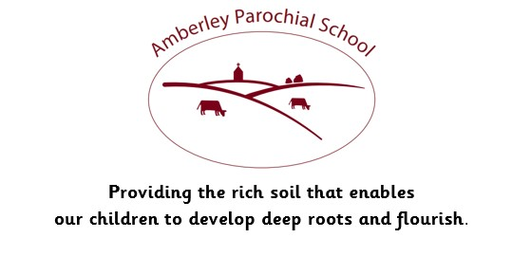

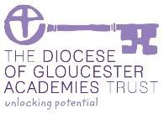

Amberley Parochial School

Curriculum Statement for PE

|  |
| --- |
| **Vision** |
| ***Providing the rich soil that enables our children to develop deep roots and flourish*** |
| **Intent** |
| At Amberley, we aim to inspire all children and for each child to fulfil their potential. We want the children’s experience of PE to be positive and motivating. PE enables pupils to become physically confident and this supports their health, wellbeing and fitness, providing the foundations for lifelong activity. Through PE, we develop the children’s knowledge, skills and understanding enabling them to build confidence and competence in a range of activities.  We are committed to ensuring children understand the value and importance of PE in the wider community, and are able to use their skills, knowledge and experiences to involve themselves in physical activity, in a variety of different contexts.  We provide regular opportunities for children to experience, participate in and celebrate through our lessons, clubs, and events calendar. |
| **Implementation** |
| Each child receives 2 hours of PE a week with specialist coaches or class teachers. We plan their sessions to cover a broad and full range of skills and activities. Children also have the chance to be active in a range of clubs. Children in upper key stage 2 attend swimming lessons in a local pool. They learn to swim 25 metres competently and confidently using a range of strokes. We teach in a way that children:  • have fun and experience success in sport  • can join in at their own level of development  • build and secure a range of skills  • develop good sporting attitudes  • understand basic rules  • experience positive competition  • learn in a safe environment |
| **Impact** |
| Our PE Curriculum is planned to demonstrate progression, build on, and embed current skills. We focus on progression of knowledge and skills in the. If children are achieving the knowledge and skills taught in lessons, then they are deemed to be making good or better progress.  We measure the impact of our curriculum through the following methods:   * Pupil discussions and interviewing the pupils about their learning (pupil voice). * Governor monitoring with our subject governor. * Annual reporting and tracking of standards across the curriculum. * Photo and video evidence of the pupils’ practical learning. * Use of the assessment tools provided within the PE Pal scheme. * Dedicated PE subject leader time.   The impact of our PE curriculum is also measured in the uptake of our after- school clubs, participation in School Games Network events, uptake of extra- curricular physical activities and the achievement of our Gold School Games Mark award. |
| **How we support children with Special Educational Needs in this subject area:**  We believe all pupils should have the opportunity to learn and participate to the best of their capabilities through a broad and balanced, inclusive curriculum. This means that every child, including those with a Special Educational Need, should have access to a high standard of ‘Quality First Teaching' throughout the day in every curriculum subject, including PE. Pupils who may need additional support will be encouraged to access learning at a level they achieve, but also be supported to make accelerated progress. |