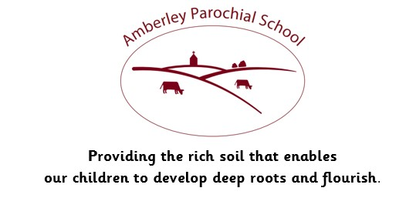



Amberley Parochial School

Curriculum Statement for Mathematics

|  |
| --- |
| **Vision** |
| ***Providing the rich soil that enables our children to develop deep roots and flourish*** |
| **Intent** |
| At Amberley Parochial School, we know that Mathematics is a skill we use daily and is an essential part of everyday life. Therefore, our mathematics mastery approach forms an important part of our broad and balanced curriculum where we endeavour to ensure that children develop an enjoyment and enthusiasm for the subject that will stay with them throughout their lives and empower them in the future.  Our mathematics curriculum is progressive and based on the White Rose Scheme of Learning that teaches in small steps from EYFS to Year 6. As a school, we recognise that the key to unlocking the potential in our children is through the development of basic mathematical skills and the understanding of mathematical concepts. We therefore place great emphasis on the use of concrete resources and pictorial representations at all ages, to enable children to fully understand the concepts and principals, when presented with abstract calculations and questions. Mistakes and misconceptions are used as an essential part of learning and provide challenge to deepen understanding, while reasoning and problem-solving, especially verbally, play a part in all mathematics lessons as we strive to ensure that we do something to generate mathematical thinking every lesson. |
| **Implementation** |
| Following the National Curriculum through the support of the White Rose Maths Scheme, mathematics learning is centred around fluency, reasoning and problem solving for all. Progression documents such as our calculation policy and the mixed-age planning are carefully used to ensure that children are not being stretched beyond expectations, but rather deepened within them. Within daily teaching, children have links to previous/current learning through the Flash Back 4 activities. Daily assessment is incorporated throughout the lesson through live and verbal feedback. Termly assessments are used as a diagnostic tool to ensure that teachers are adapting learning to meet the needs of all children and ensure that any necessary interventions are targeted specifically to meet the needs of the children. Where children require additional support, ‘scaffolds’ are used to support children further to ensure that they have secured the small step before moving on. These ‘scaffolds’ may be in the form of returning to concrete resources or pictorial representations. For children who understand a concept quicker, challenges are used to deepen and challenge learners further within the curriculum area.  Rapid recall skills and times tables play an important part in our maths learning, with children developing their fluency in rapid recall of tables up to 12 x 12 throughout school, with their progress structured through the sequential Amberley Club Maths sheets. Problem solving and reasoning are central to all mathematics teaching, with probing questions that generate thinking and the use of collaborative problem solving, leading up to be not exclusively in GECKO Maths sessions, featuring in all lessons. |
| **Impact** |
| As a school, we strive to ensure our children’s progress is in line with or exceeds national expectations, whatever their starting point in primary education. Using the mastery White Rose curriculum will ensure our pupils are academically prepared for life beyond primary school and throughout their educational journey. Children are encouraged to talk and challenge mathematical concepts. Through this, children can address misconceptions, experience challenge, provide reasoning and problem solve together. We often ensure that mathematical concepts have real, everyday references to them, allowing children to make connections between their learning and life.  We aim to ensure that all pupils, on leaving Amberley Parochial School, will:   * Have a love and enjoyment of mathematics * Be fluent in arithmetic skills * Approach reasoning and problem-solving tasks with resilience and ‘mathematical grit’, and be able to draw on a variety of strategies to help solve these problems * Use mathematical language accurately and confidently to express their ideas * Understand the importance of Maths and its links to other subjects and the wider world |
| **How we support children with Special Educational Needs in this subject area:**  We believe all pupils should have the opportunity to learn to the best of their capabilities through a broad and balanced, inclusive curriculum. This means that every child, including those with a Special Educational Need, should have access to a high standard of ‘Quality First Teaching' throughout the day in every curriculum subject. Teachers use a range of teaching and learning styles and appropriate learning objectives are set for all children with a curriculum matched to their needs.  In mathematics, our pupils with a Special Educational Need are supported by using a small step progression of skills combined with structures or materials that allow them to access their learning. This allows children to make progress from whatever their starting point. Access arrangements might include classroom-organisation and grouping, visual resources, memory aids, pre-learning of key vocabulary and concepts, and in some cases 1:1 and personalized teaching. |