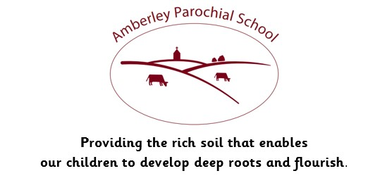

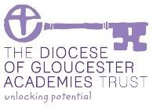

Amberley Parochial School

Curriculum Statement for History

|  |
| --- |
| **Vision** |
| ***Providing the rich soil that enables our children to develop deep roots and flourish*** |
| **Intent** |
| At Amberley Parochial School, it is our intention that History will inspire the children’s curiosity about the past in Britain and the wider world. The children are taught to consider how the past influences the present, what past societies were like and how beliefs and cultures influence people’s actions. As they do this, children develop a chronological framework for their knowledge of significant events and people as well as an understanding of how these are connected.  We consider the development of historical skills as important as the gathering of historical knowledge. The children are taught to think, talk and behave as Historians and Archaeologists, posing their own historically valid questions, as well as examining, interpreting and evaluating a variety of sources in order to make deductions about the past. The children investigate how and why the world has changed as well as what we can learn from the past to make the future a better place. They learn to communicate this in a variety of ways, using increasingly more complex subject-specific vocabulary. |
| **Implementation** |
| At Amberley, we want our curriculum to ignite curiosity, inspire a love of learning and build knowledge and skills, giving our children exciting experiences, which inspire awe and wonder in the world around them. Geography is taught in a block to immerse pupils in their learning. This immersion enables children to build on their learning in a meaningful way, making links with prior and current ideas and concepts.  In EYFS, children learn about their own lives since they were born. Children learn about the lives of significant individuals and changes that have occurred over time, developing the relevant historical vocabulary to prepare them for Key Stage One.  Within Key Stage One, children participate in thematic studies to develop an awareness of the past, understand key people and events and begin to develop skills to study history, such as hypothesising and questioning. Where possible, this is focused around a local study of people and places, making it as relevant as possible to the children.  Within Key Stage Two, topics within history start to look at local and World History more closely and explore what we can learn from the past and Historical civilizations. Progression is achieved by using the objectives drawn from the year group expectations, detailing specific knowledge, skills and understanding, closely linked to the National Curriculum.  School visits are used within the History curriculum to develop a deeper understanding of the time periods studied and to inspire the children so that they have a lifelong love of History. |
| **Impact** |
| To monitor the impact of their teaching, teachers carry out continuous assessment. They use short-term assessments, matched to the specific year-group expectations, to adjust their planning. At the end of each unit, teachers track the children’s progress and attainment. Regular opportunities for revisiting prior learning are built into curriculum time. Teachers are aware of the key skills that have been covered in previous years and understand how their teaching builds on this. The subject leader monitors the impact of what has been taught by reviewing planning, undertaking regular book looks and talking to pupils and staff. |
| **How we support children with Special Educational Needs in this subject area:**  We believe all pupils should have the opportunity to learn to the best of their capabilities through a broad and balanced, inclusive curriculum. This means that every child, including those with a Special Educational Need, should have access to a high standard of ‘Quality First Teaching' throughout the day in every curriculum subject, including History.  In History, our pupils with a Special Educational Need are supported through use of our carefully considered Long Term Plan that regularly builds on prior learning. Through making links to what pupils already know, this allows children to make progress from whatever their starting point. The variety of different teaching styles used also benefits pupils with a Special Educational Need, as well as differentiation within tasks and outcomes in the subject. Guidance on differentiation is provided to all staff. This differentiation might include classroom organisation and grouping, visual resources, pre and over learning of key vocabulary and questioning, enabling all children to reach their full potential in Geography. |