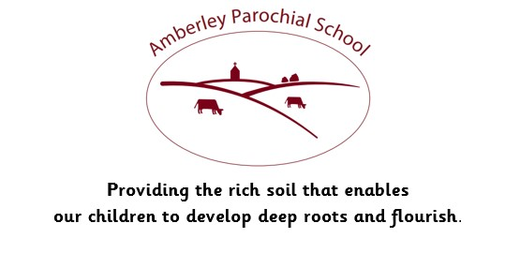

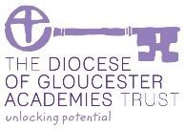

Amberley Parochial School

Curriculum Statement for Music

|  |
| --- |
| **Vision** |
| ***Providing the rich soil that enables our children to develop deep roots and flourish*** |
| **Intent** |
| At Amberley, it is our intent that children gain a firm understanding of what music is; through listening, singing, playing, evaluating, analysing and composing across a wide variety of historical periods, styles, traditions and musical genres. Our objective is to develop a curiosity for the subject, as well as an understanding and acceptance of the validity and importance of all types of music. We are committed to ensuring children understand the value and importance of music in the wider community, and are able to use their musical skills, knowledge and experiences to involve themselves in music, in a variety of different contexts.  We provide regular opportunities for children to experience and perform live music through our lessons, concerts, Collective Worship, specialist tuition, clubs, and class and key stage performances. |
| **Implementation** |
| At Amberley, we deliver our curriculum through the Charanga Musical School Scheme, which supports all the requirements of the national curriculum for Music. As students work through it they sing, play tuned and untuned instruments, listen to recorded and live music, and compose and improvise using the interrelated dimensions of music. They learn about the history of music, exploring a range of musical styles and traditions, while using and understanding staff and other notations.  The music curriculum ensures children sing, listen, play, perform and evaluate. This is embedded in the classroom activities as well as the weekly singing assemblies, various concerts and performances and the learning of instruments. Through the musical program Charanga, teachers are able to produce inclusive lessons for all children to access the musical curriculum in a fun and engaging way, further promoting a love of learning. Charanga lessons are planned in sequences to provide children with the opportunities to review, revise, deepen and apply their understanding. Playing various instruments enables children to use a range of methods to create notes, as well as how to read basic music notation. They also learn how to compose, focusing on different dimensions of music, which in turn feeds their understanding when listening, playing, or analysing music. |
| **Impact** |
| Our Music Curriculum is planned to demonstrate progression, build on, and embed current skills. We focus on progression of knowledge and skills in the different musical components and teaching of vocabulary also forms part of the units of work. If children are achieving the knowledge and skills in lessons, then they are deemed to be making good or better progress.  We measure the impact of our curriculum through the following methods:   * Pupil discussions and interviewing the pupils about their learning (pupil voice). * Governor monitoring with our subject music link governor. * Annual reporting and tracking of standards across the curriculum. * Photo and video evidence of the pupils’ practical learning. * Use of the assessment tools provided within the Charanga scheme. * Dedicated Music subject leader time.   The impact of our music curriculum is also measured in the uptake of our music after school clubs and uptake of additional music 1:1 teaching. |
| **How we support children with Special Educational Needs in this subject area:**  We believe all pupils should have the opportunity to learn to the best of their capabilities through a broad and balanced, inclusive curriculum. This means that every child, including those with a Special Educational Need, should have access to a high standard of ‘Quality First Teaching' throughout the day in every curriculum subject, including Music.  In music, our pupils with a Special Educational Need are supported by using a scheme that provides a familiar structure throughout all lessons in every year group. The spiral curriculum allows children to make progress from whatever their starting point and guidance on differentiation is provided to all staff. This differentiation might include classroom organisation and grouping, visual resources, pre and over learning of key vocabulary and questioning, enabling all children to reach their potential in Music. |