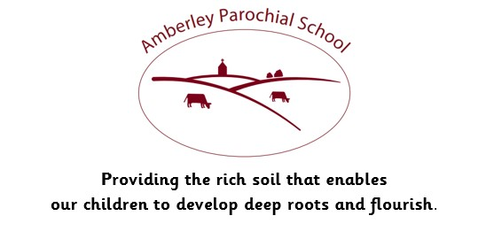

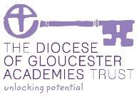

Amberley Parochial School

Curriculum Statement for Art

|  |
| --- |
| **Vision** |
| ***Providing the rich soil that enables our children to develop deep roots and flourish*** |
| **Intent** |
| At Amberley, we aim to inspire all children and for each child to fulfil their potential. Our intent is for all Learners to develop • The ability to create pieces of art confidently and adventurously from observation, memory and imagination.  • The ability to explore and invent, develop ideas and communicate through artwork  • Develop a knowledge and understanding of a range of artists and genres  • The ability to think and use knowledge and understanding to inform, inspire and interpret ideas, observations and feelings. • The ability to independently select and use materials, processes and techniques  • The ability to reflect on, analyse and critically evaluate their own work and that of others.  • A passion for and a commitment to the subject  ***‘Creativity is inventing, experimenting, growing, taking risks, breaking rules, making mistakes, and having fun.’***  ***– Mary Lou Cook*** |
| **Implementation** |
| At Amberley, our Art curriculum is taught through a two-year rolling program, matched to the National Curriculum expectations for EYFS, KS1 and KS2. Art units are taught in blocks to ensure children are immersed in their learning and have deeper experiences that develop their artistic skills. The subject leader worked with teachers to ensure the units covered were relevant to the children, contained the correct skills and challenge and showed a clear progression of skills.  Our Amberley Immersion Curriculum ensures that opportunities are provided to:   * Develop **Substantive Knowledge.** Thisisthesubject specific content of art and design, taught through research and practice and the exploration of a diverse range of artists and artistic genres. It encompasses the cultural and contextual understanding of artists and their work. * Develop **Procedural Knowledge-** represented by the stages of ‘visual literacy’, ‘generating ideas’, ‘creating’ and ‘presenting’.  This includes practical knowledge and technical proficiency of skills across multiple mediums. * Opportunities for self-and peer evaluation. * Develop wider-community connections and external exposure through competitions, art club, etc. |
| **Impact** |
| The children of Amberley will understand and develop the traits and skills needed to become Artists. They understand that Art is about expressing yourself visually, and they aim to behave like artists by being creative and observant. They will accumulate skills using a range of media and develop an understanding of a range of pre-identified artists.  Our Art curriculum is planned to focus on the progression of knowledge and skills. If children are achieving the knowledge and skills taught in lessons, then they are deemed to be making good or better progress.  We measure the impact of our curriculum through the following methods:   * Pupil discussions and interviewing/surveying the pupils about their learning (pupil voice). * Governor monitoring with our subject governor. * Annual reporting and tracking of standards across the curriculum. * Photo evidence of the pupils’ practical learning. * Dedicated subject leader time.   The impact of our Art curriculum is also measured in the uptake of our after- school Art club which runs at full capacity with 18 children attending weekly. We are proud of our participation and success in competitions such as the Rotary Young Artist award and The Royal Academy Summer Exhibition. We also engage in wider community events including the Amberley Cow Hunt and the Festival of Wonder in Stroud, as well as taking groups of children to support elderly residents with art activities at Winslow House, a local care home. |
| **How we support children with Special Educational Needs in this subject area:**  We believe all pupils should have the opportunity to learn and participate to the best of their capabilities through a broad and balanced, inclusive curriculum. This means that every child, including those with a Special Educational Need, should have access to a high standard of ‘Quality First Teaching' throughout the day in every curriculum subject, including Art.  Art is a way to communicate and respond to experiences. Every child’s response is unique and activities in Art are planned which allow pupils to respond according to their abilities, with appropriate adaptation with support, resources and outcome.  Teachers will provide instruction and guidance on technical processes to take account of individual needs. |